**Example Abstract:**

The ability for people to cooperate, especially in the presence of incentives to defect and benefit from other’s cooperation (i.e., social dilemmas), provides solutions to key challenges faced by dyads, groups, organizations, and societies. There is a substantial body of empirical research on cooperation in social dilemmas dating back to the 1950’s. This work has been directed by diverse theoretical approaches from different disciplines, such as psychology, economics, sociology, and biology, and to date there is no dominant theoretical paradigm directing research on cooperation. Recently, the history of research on cooperation has been coded and represented in a standardized knowledge graph, allowing scientists to utilize novel methodologies to analyze patterns across the literature (i.e., cooperation databank; CoDa). Until now, only quantitative summaries of this databank have been attempted. This paper goes beyond prior work by using the novel *text mining systematic review* method to qualitatively summarize #,### papers included in CoDa. We begin with a brief narrative review of relevant phenomena discussed about cooperation. Next, we analyze text data from paper abstracts using text mining approaches, and use term frequency as an indicator of relevance and term co-occurrence as an indicator of association. We found…. These findings suggest…

**Introduction**

Points to make in the intro of the intro:

There exist a diversity of disciplines that study cooperation, which often use different theory and terms for sometimes similar constructs.

There is a lack of integration across these disciplines (maybe show the two major communities in citation network of Coda)

Text analysis can reduce bias in providing an overview of a literature, such as confirmation bias

Text analysis can provide a broad overview, relative to narrative reviews and meta-analyses that are often restricted to specific phenomenon (e.g., ingroup favoritism, punishment/reward).

*Major Contributions include:*

1. Identify phenomena for theory development of cooperation
   1. Specifically identify most relevant phenomena for cooperation
2. Generate new insights about associations between constructs in the literature.
   1. Map relationships between phenomena (co-occurrence in studies)
3. This will help to integrate the literature
4. This helps to lay the foundation for theory development

**Broad overview of past theory of cooperation (emphasizing one of the latest most influential narrative reviews on cooperation from that perspective, and the key concepts discussed in those narrative reviews).**

1. Initial work from 1950-1970’s was descriptive and lacked theory.
2. 80’s onwards in psychology has mostly involved mini-theories of effects, and categorization/classification of effects (e.g., structural versus motivational solutions) a. Van Lange, Joireman et al. (2013)
3. Game theory, and subsequently psychological game theory and behavioral economics, have direct much research from 1970’s onwards
   1. Ledyard (1995)? Ask Simon about a recent one?
4. Evolutionary theory, evolutionary game theory and evolutionary psychology, form an established theoretical approach to cooperation.
   1. Kurzban et al. (2015); Rand and Nowak (2013)
5. Theory of culture and cultural processes have also informed cooperation.
   1. Henrich et al., (2021)
6. Theory of the development of cooperation
   1. Warneken (2018)
7. Neuroscience of cooperation?

For each section we may include a paragraph that outlines some of the most important influences on cooperation from that perspective, and which have been emphasized in the narrative review.

Maybe in this section we make a point that different approaches have used different language to discuss highly similar phenomena. For example, psychologists study social motives/values, while game theory discusses social preferences, evolutionary theory discusses welfare-tradeoff ratios, and cultural theory discusses cultural values (e.g., benevolence/univeralism).

Limitations of existing theory include: No integration across disciplines, different levels of explanation that have not been inter-related, different levels of specificity to phenomena, different languages across disciplines, disciplines are stuck in citation bubbles or communities.

**Discussion**

1. What terms are mentioned that are not discussed in theory?
2. Can we also use coda to estimate the associations between variables included in the co-occurrence network? We can do this if “cooperation” is considered a node in that network.

*Strengths*

1. The number of papers we include in the review, better than all prior efforts and so this is a highly comprehensive overview
2. We utilize CoDa as a resource and demonstrate the advantages of establishing this kind of resource (this paper would be in a special issue of Psych bull on resources). Maybe we could make the analyses easily reproducible with new, incoming papers, and so a kind of living review.
3. Results are reproducible
4. Method is an objective technique to review a literature
5. This provides an initial, crucial, step in theory development

*Limitations*

1. Analysis does not consider the meaning of words
2. The Analysis does not consider the nature of the association between constructs
3. There are several subjective decisions made during the analyses.

**Ideas to consider for the paper:**

When developing CoDa we created an ontology of concepts discussed in past research that are predictors of cooperation. Below is a bubble plot of all these predictor, with the size of the bubble corresponding to the number of studies in which that concept was studied. Would this be a relevant “baseline” to compare the results of the text analysis? I’m curious if the text analysis would actually discover anything additional to our ontology.

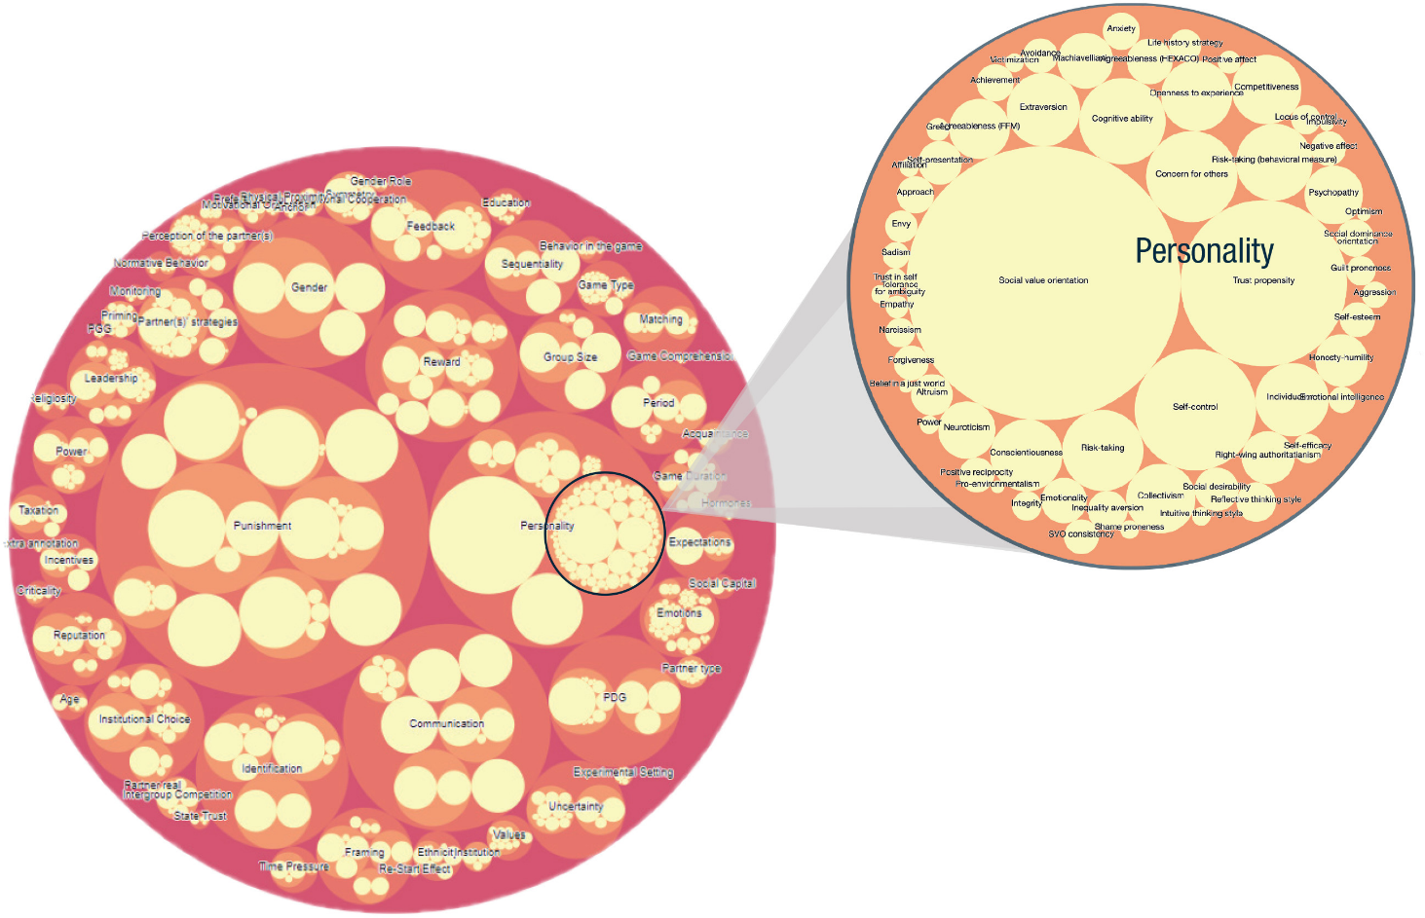

Would it be reasonable to integrate the output of the text analysis with output from meta-analyses, which would indicate the strength and direction of each association (at least with cooperation)? As mentioned in the emotion regulation review, this is a limitation of the text analysis approach, and with CoDa we can address that limitation.